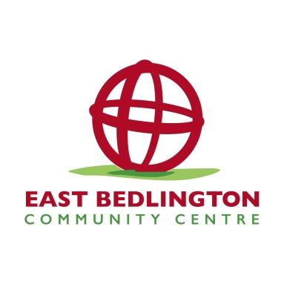 East Bedlington Community Centre Booking Form

16 & 17 Station Street, Bedlington, NE22 7JN

01670 828808

eastbedlingtoncommunitycentre@gmail.com

**Please provide details of the person to be invoiced:**

Name:

Address:

Post Code:

Contact Telephone Number:

Email Address:

**Date of booking: Time from: To:**

**Do you require time prior to the booking to set up?** (This will be charged according to the hourly rate/proportion of hourly rate. Style of room will be set up free of charge) **Y / N**

**If yes, please state amount of time requested:**

**Estimated number of people attending:**

**Group/Organisation Name:**

**Type of activity/nature of booking:**

**If this meeting private or open to members of the public?:**

If the room is to be hired for an activity involving children or vulnerable adults, we will require a copy of your safeguarding policy.

**Room Required** (please tick)**:**

**Bayard  Ticket Office  Sidings**

**Platform 1  Platform 2  The Buffet Car **

**Style of room set-up** (please see details on set-up page)**:**

**Theatre Style  Classroom Style  U-Shaped  Empty**

**Cabaret Style  Banquet Style  Boardroom Style **

**Preferred method of payment:**

**Cash on the day  Electronic invoice and bank transfer **

**Please verify you have read the and understood the terms and conditions, and confirm that all information you have provided is correct:**

Signed: Date:

 East Bedlington Community Centre Booking Form

16 & 17 Station Street, Bedlington, NE22 7JN

01670 828808

eastbedlingtoncommunitycentre@gmail.com

**Room Hire Charges**

|  |  |
| --- | --- |
| Room | Hourly Rate |
| The Ticket Office | £11 |
| The Bayard | £12 |
| The Sidings | £12 |
| Platform 1 (includes use of Buffet Car FOC if required) | £20 |
| Platform 2 | £20 |
| The Green Room | £10 |
| The Buffet Car | £20 |

**Please Note:** Corporate hire will also incur VAT at the current rate of 20%

**Other Services/Equipment**

|  |  |
| --- | --- |
| Tea and Coffee | £1 a head, minimum charge £10 |
| Tea Coffee + Biscuits | £1.25 a head, minimum charge £10 |
| Hot water only | FREE |
| Hot water + cups | FREE but cups MUST be washed up |

**WiFi –** There is WiFi available in the centre – please ask a member of staff upon arrival for code/setup instructions.

 East Bedlington Community Centre Booking Form

16 & 17 Station Street, Bedlington, NE22 7JN

01670 828808

Eastbedlingtoncommunitycentre@gmail.com

**Room Set-ups**

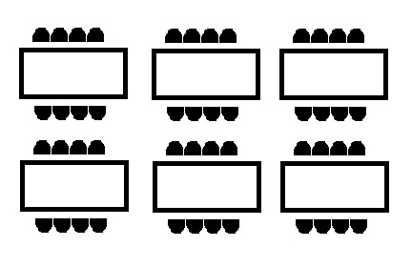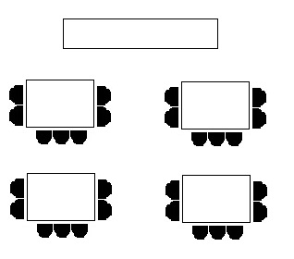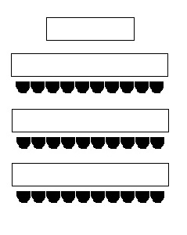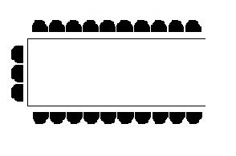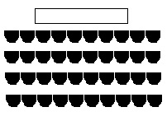

Banquet Style Boardroom Style

Theatre Style U-Shaped

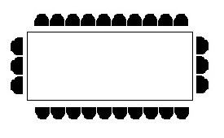

Cabaret Style Classroom Style

 East Bedlington Community Centre Booking Form

16 & 17 Station Street, Bedlington, NE22 7JN

01670 828808

eastbedlingtoncommunitycentre@gmail.com

1. The ‘Centre’ shall mean East Bedlington Community Centre.
2. All bookings are considered provisional until a completed and signed Room Booking Form has been received by the Centre.
3. The Centre reserves the right to refuse or to terminate future bookings if meetings/activities taking place within the Centre are likely to cause a breach of the peace, or are causing a disturbance or disruption to the main function of the building.
4. All invoices will be calculated using the scale set out in the Room Hire Charges. All bookings must start and end at the stated time. Any additional time periods at the start of a booking, or and bookings running past the agreed time will be charged in accordance with the hourly room hire price.
5. In the event of cancellation within 24 hours of a booking, or a non-arrival, the full cost of room hire will be charged.
6. The Centre shall not be liable for any loss, damage, cost or expense incurred or suffered, including but not limited to personal injury or death, or damage to personal property, which may arise in consequence or directly from use of the Centre.
7. The Centre does not accept liability for loss or damage to any personal belongings of anyone attending a booking.
8. The person named on the booking will be liable for any damage caused during their booking to any room, facility, equipment or furniture.
9. The Centre will not be liable in failing to provide facilities in the event it is unable to do so by causes beyond it’s control, including but not limited to floor, fire, storm, industrial action or civil disturbance.
10. The Centre reserves the right to change/amend/cancel bookings to accommodate the needs of the Centre. Where possible we will endeavour to provide a suitable alternative in this situation.
11. At the start and end of your booking you should report to a member of Centre staff, who will grant you access to your room and advise you of any Health and Safety information.
12. Any visitors to the Centre are required to comply with all Health and Safety instructions, as well as general guidelines applicable to use of the Centre.
13. Public Liability, risk assessment and fire safety information is available if required, however it is the responsibility of the person booking the room to ensure emergency procedures and Health and Safety information is communicated to anyone attending their booking.
14. Certain activities/items are prohibited within the Centre. These include, but are not limited to; bouncy castles, animals, confetti, adult entertainment and gambling.
15. It is the responsibility of the person hiring the room to inform Centre staff if anyone in their group would require assistance in an emergency evacuation.

 East Bedlington Community Centre Booking Form

16 & 17 Station Street, Bedlington, NE22 7JN

01670 828808

eastbedlingtoncommunitycentre@gmail.com

1. If the room is being hired for any activity that has a potential safeguarding risk (working with children/young people or vulnerable adults) the Centre will require a copy of your safeguarding policy prior to your booking taking place. For any activity that is **not** a private party, for example a class, drop-in session or anything open to the general public, we will also require a copy of your public liability insurance prior to your booking taking place. By signing and returning the booking form you agree to provide both of these documents before the time of your booking.
2. If you are planning on bringing electrical equipment into the Centre to use for your booking, this equipment should be in good working order, and if more than 2 years old, will require a PAT Test. The Centre does **not** provide this service, and it will need to be carried out before your booking takes place. This is also applicable for third parties bringing equipment into the centre, for example DJs/bands/caterers.
3. Where third party organisations are involved in a booking (for example a DJ at a party, a guest speaker in a class) we would encourage them to contact us prior to the booking to ensure they are fully aware of the facilities available, times of the booking etc. The Centre can not guarantee that third parties attending bookings will be accommodated if the requirements have not been made clear at the time of booking.
4. Any changes or additions to these terms must be made in writing by the Centre; no verbal discussions, agreements or arrangements will be binding. If any changes to the terms are to be requested, this must be made in writing to eastbedlingtoncommunitycentre@gmail.com
5. All children/young people **must** be supervised at all times when using the Centre. This includes use of the lift; no young person under the age of 14 is permitted to use the lift unsupervised.
6. The Centre is a **no smoking** venue, and this includes any sort of e-cigarettes or vaping equipment.
7. Only alcohol purchased on the premises may be consumed; the Centre operates a ‘Challenge 25’ policy, and therefore anyone who appears to be under the age of 25 will require ID to be served alcohol.
8. The Centre operates a ‘Zero Tolerance’ policy towards abusive and violent behaviour. Any individual found to be acting in this way towards any member or staff, or any other Centre user, will be asked to leave the premises immediately. In the event that further assistance is required, local police will be called and action will be taken.
9. Payment - All bookings must be paid for in advance, and balances cleared by no later than the date of the booking. For recurring room hire, account payment facilities may be arranged. When hiring ‘Platform 1’ we will require a £20 deposit at the time of booking to secure the room for you.
10. By completing and returning the Centre booking form, you acknowledge and accept all terms and conditions as stated above, and confirm that all details given on the form are correct.